**Project Report Template**

**Property Management Application using Salesforce**

**Introduction**

A property management system (PMS) is an essential tool for managing properties, whether it is a hotel, a vacation rental, or a real estate business. Salesforce is a powerful customer relationship management (CRM) platform that can be used to build a PMS solution that provides several benefits. Here are some reasons why a property management system using Salesforce is important:

**Centralized Data Management:** A PMS using Salesforce provides a centralized system for managing property-related data. This includes reservations, guest profiles, inventory management, pricing, and other important details. By having all of this data in one place, property managers can quickly access and analyze it to make informed decisions.

**Customizable:** Salesforce is highly customizable, which means that a PMS built on this platform can be tailored to the specific needs of the property management business. This allows property managers to create workflows that are efficient and effective, resulting in a better guest experience.

**Automation:** Salesforce's automation capabilities can help streamline property management processes, such as check-in and check-out, billing, and inventory management. This saves time and resources and reduces the risk of human error.

**Reporting and Analytics:** Salesforce's reporting and analytics capabilities can provide property managers with insights into their operations. This can help them make data-driven decisions, optimize pricing, and identify areas for improvement.

**Integration:** Salesforce can be integrated with other systems, such as accounting software, marketing automation tools, and booking engines. This ensures that property managers have a seamless experience across different platforms and can easily manage all aspects of their business.

In summary, a property management system using Salesforce can help property managers streamline their operations, improve guest experience, and make informed decisions based on data and analytics.

**Problem Definition and Design Thinking**

**Empathy Map**

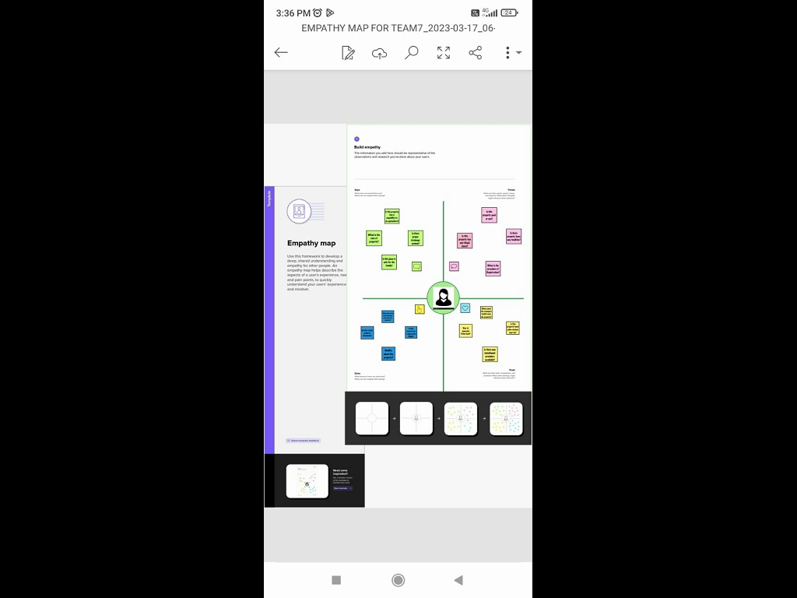

<https://app.mural.co/invitation/mural/ppssteam9015/1679024343897?sender=u03f14a174af82897f13f8298&key=6b7a1ca3-5562-490c-a488-c012cf68c43c>

**Brain Storming Map**

<https://app.mural.co/invitation/mural/ppssteam9015/1679124459138?sender=u438a9ca45cac0a6361796021&key=b1ef2d7c-98fa-4d4c-9add-204af892b08d>

**Result**

**Data Model**

|  |  |  |  |  |  |  |  |  |  |
| --- | --- | --- | --- | --- | --- | --- | --- | --- | --- |
| **Object 1**  **Buy** | |  |  | | --- | --- | | **Field Label** | **Data Type** | | **Create a Property Type** | **Factory** | | **Discount** | | **State** | | **City** | | **Annual Amount to be Paid** | |
| **Object 2**  **Rent** | |  |  | | --- | --- | | **Field Label** | **Data Type** | | **Rent** | **Factory** | | **Rental City** | | **BHK Type** | |
| **Object 3**  **Loan** | |  |  | | --- | --- | | **Field Label** | **Data Type** | | **Loan ID** | **Factory** | | **Interest Rate** | | **Term** | | **Annual Loan** | | **Total Loan Installment** | | **Loan Repayment** | | **Loan Amount** | |

**Activity and ScreenShot**

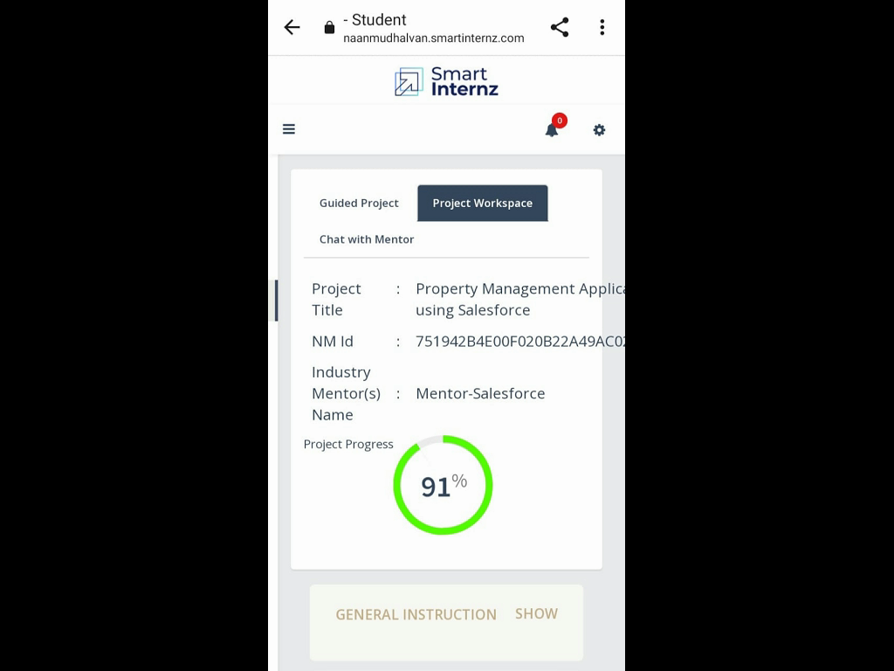

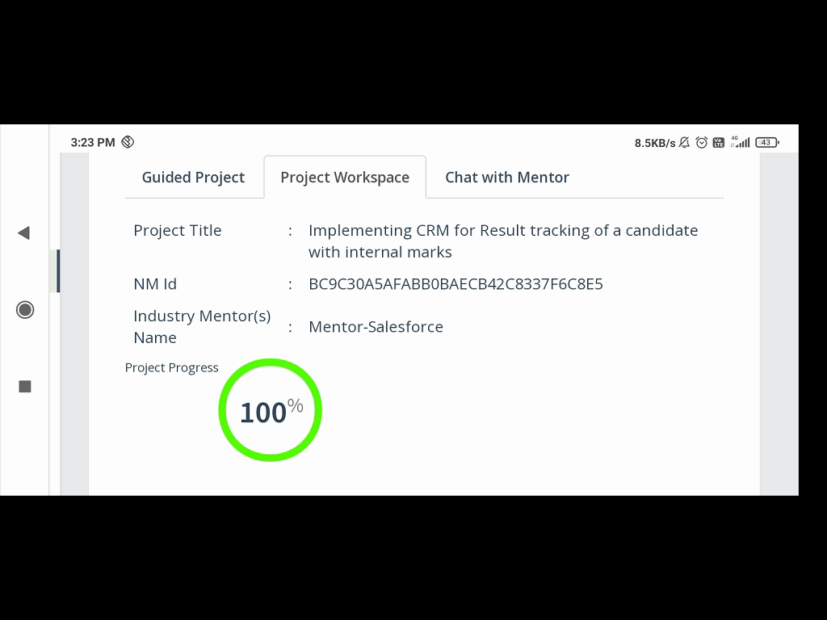

**Trailhead Profile Public URL**

 Team Leader : <https://trailblazer.me/id/ranir13>

Team member 1:<https://trailblazer.me/id/mani12vgg>

Team member 2:<https://trailblazer.me/id/priys85>

Team member 3:<https://trailblazer.me/id/pravv32>

**Advantage and Disadvantage**

**Advantage:**

**Integration:** A property management system using Sales Force can integrate with various third-party applications like booking engines, revenue management systems, accounting software, and more, thus providing a unified platform to manage all operations.

**Automation:** It automates various tasks like booking management, housekeeping, check-in and check-out procedures, inventory management, and more, thus reducing human error and improving efficiency.

**Scalability:** As the business grows, the system can be easily scaled to accommodate additional properties, staff, and services.

**Data Analysis:** Sales Force provides robust reporting and analytics capabilities, enabling the property manager to gain insights into key performance indicators, such as occupancy rates, revenue, and customer satisfaction.

**Customer Relationship Management:** With Sales Force, it is easy to manage customer data and communicate with guests through various channels like email, SMS, and social media, thus improving customer engagement and loyalty.

**Disadvantages:**

**Cost:** Implementing a property management system using Sales Force can be expensive, especially for small businesses.

**Learning Curve:** Sales Force is a complex system, and it can take time and resources to train staff to use it effectively.

**Integration Challenges:** Integrating Sales Force with existing systems can be challenging, and there may be compatibility issues with certain third-party applications.

**Dependence on Technology:** A property management system using Sales Force is heavily reliant on technology, and any system downtime or technical glitches can disrupt operations and cause inconvenience to guests.

**Data Security:** Storing guest data and financial information in the cloud can pose security risks, and it is essential to implement robust security measures to protect sensitive data.

|  |  |
| --- | --- |
|  |  |

**Applications**

* The level of CRM accessibility and ease of use
* Advanced reporting system
* Contact management
* The level of customer support
* The ability to tailor the platform to fit your needs
* Lead management
* Features for managing lease and sale inquires
* Ability to import/export data
* Intuitive design
* The level of data security
* Options for tenants
* Instant document sharing
* Built-in communication tools

**Conclusion**

* scheduled structure
* improved follow-ups
* better response time
* .marketing automation
* enhanced client retention
* productive use of social media
* elevated conversation rate
* .discard competitions
* instant evaluation
* centralized information

|  |  |
| --- | --- |
|  | **Future Scope**  **Most In-Demand Salesforce Career Opportunities**  **1. Salesforce Administrator**  Salesforce Admins are in charge of operational responsibilities like bug fixes, new functionality implementation, training new users, and assuring customer satisfaction. A Salesforce administrator can work for anyone who isn’t in the IT industry.  A Salesforce administrator’s duties and responsibilities are numerous and vary across organizations. However, some common tasks include modifying and improving the Salesforce platform to improve the organization’s business processes and workflows.  **2. Salesforce Developer**  Salesforce developer is a career option for those with strong coding/programming and technical skills. The Salesforce developer is a technical role with responsibilities that go beyond programming.  Salesforce platform developers are experts in the creation of Salesforce apps and components. They collaborate with the sales and marketing departments. Debugging, unit testing, quality assurance, and user documentation are also taken care of by Salesforce developers.  **3. Salesforce Consultant**  Salesforce Consultants help organizations optimize and implement Salesforce products and services that are scalable and cost-effective. A Salesforce consultant’s responsibilities include configuration and project management throughout the project lifecycle.  **4. Salesforce Architect**  This position takes a lot of expertise and attention from the individual. Architects are in charge of developing Salesforce following best practices and guidelines, and they must be familiar with technical aspects like coding methodologies and declarative functionality. Salesforce architects are specialists in the inside workings of the system. |